Draft: CO, NOx and NMVOC emissions for harmonized emission inventory dataset.

- Datasets used in this analysis:

This harmonized dataset is based on global emission inventories (EDGAR, RETRO, IIASA), regional emission inventories (REAS, TRACE-P), individual studies for India and China and country reports to international forums such as the UNFCCC and EMEP. Description, citation and abbreviation of the different inventories is as follows:

Global emission inventories:
RETRO: results form the Retro project (Schultz. Ed. 2007) where sector emissions of CO and NMVOC and NOx where provided by Martin Schultz and Tinus Pulles through personal communication.
IIASA: CO and NO_{x} Emissions from the year 2000 from scenario calculation by the International Institute for Applied Systems Analysis (IIASA) for ACCENT and the PhotoComm experiment as described in Dentener et al. (2004) and Cofala et al (not dated).
EDGAR: CO, NMVOC and NO_{x} emissions as published in the EDGARv32 FT2000 dataset (Olivier et al., 2005 and Van Aardenne et al. 2005).

Regional emission inventories (Asia)
TRACEP: CO, NO_{x}, and NMVOC emissions in Asia as calculated for the TRACE-P project for the year 2000 (Streets et al. 2003).
REAS: CO, NOx and NMVOC emissions as calculated in the Regional Emission Inventory in Asia (REAS), Ohara et al. 2007.

National Emission Inventories:
ZHANG: Inventory of NOx emissions in China as published in Zhang et al. (2007).
WEI: Inventory of NMVOC emissions in China as published by Wei et al. (2008).
GARG: Inventory of NOx and CO emissions in India as published by Garg et al. (2006).
UNFCCC: National emission inventories for the year 2000 by Annex I countries and selected non-Annex I countries as presented on the website of the UNFCCC (http://unfccc.int/ghg_data/ghg_data_unfccc/data_sources/items/3816.php )
- Analysis of the emissions data.

As discussed by the emissions experts’ participation in this harmonization exercise the emission of different emission inventories are evaluated for selected world regions and emissions sectors (see Table 1 as illustration). The world regions are according to the IMAGE 19 regions, whereas the emission source groups are resulting from discussion between emission inventory experts and the IAM community.

With:
ENE: Energy industry (production, power plants and fuel conversion (IPCC, 1A1+1B)
IND: Industrial processes and combustion (IPCC 1A2, 2A, 2B, 2C. 2D and 2E)
TRA: Land transport (IPCC 1A3b, 1A3c, 1A3e)
RCO: Residential and commercial sector (IPCC 1A4)
SLV: Solvents application and production (IPCC 3)
AGR: Agriculture, animal and soil production (IPCC 4A, 4B, 4C, 4D and 4G)
AWB: Agricultural waste burning (IPCC 4F).
WST: Waste (IPCC 6A, 6B, 6C,6D)

Note1 : Savannah burning and other land use emissions are covered by the section on biomass burning. Emissions from agricultural waste burning are presented here but there might be an overlap with biomass burning emissions.
Note 2: Emissions from international shipping and aviation are discussed in section ?

Providing a harmonized emission dataset for any purposes is not a straightforward activity. If one would evaluate different emission inventories on accuracy and completeness of emissions, one would need to analyze and compare each inventory on used activity data and emissions factors and the underlying data and assumption on technology and abatement measures. Also through comparison with model results large under- or overestimation of emissions in the inventory should be identified. For two reasons such a detailed analysis has not been performed here:

First, the inventories discussed in this document present their results for different source categories, compounds and geographical detail. Only national inventories of Annex I countries submitted to the UNFCCC are comparable for source categories. All other inventories use their own definition of emission sources. In this study, the results of different inventories are grouped in the source categories as shown in Table 1. For some studies it was not possible to use sector data and only national totals are shown (e.g. REAS). For other studies it was difficult to define emissions a being under the energy or industry sector.

Second, comparison of inventory parameters like activity data or emission factors has not been possible in this activity. Not only is this data not available in all detail between the inventories (copyright issues, practical reasons) but also the duration to perform such an comparison would go beyond several months.

In order to provide harmonized data to the IAM community the following procedure has been applied:

To facilitate comparison between inventories either the region totals are compared or for selected regions, the largest emitting countries are compared.

WE NEED TO MAKE A CHOICE BETWEEN THE FOLLOWING

- Priority to national detail: order of selection:
- National data selected for
a. Annex I countries if the reported year is 2000. North America, OECD Europe, Mexico, Japan, Australia, New Zealand. For Canada the data as reported to the CLTRAP convention is selected. Exception is Eastern Europe where reported emissions from several countries seem to low (e.g. Poland).
b. For Asia, data from the publications by Zhang, Wei and Garg has been selected.
- Regional data selected when no national data available. For Asia data taken from TRACEP
- Global inventory data selected: for remaining regions by default the EDGAR has been selected.

- Consistency as criteria: Only EDGAR data applied because of consistency between different sectors and completeness over sectors and countries. An illustration of the uncertainty range can be provided based on the results by country/region and sector according the other inventories.

- Statistical choice: Emissions are provided as median value of all inventories analyzed. This means we assume that all inventories are right/wrong of same quality.
Results:

Table 1: CO emissions by world region including detail for selected countries based on selection method 1 (Unit Gg CO)

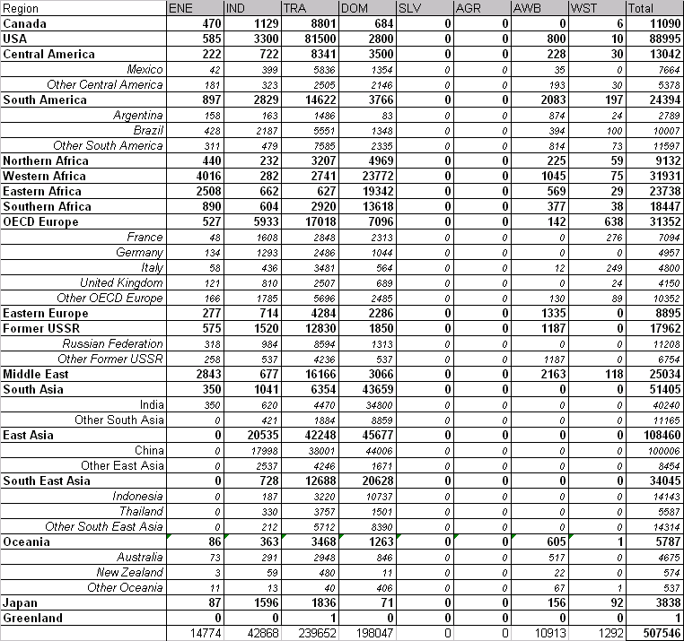

Table 2. CO emissions by world region including detail for selected countries using EDGAR as default (Unit Gg CO).

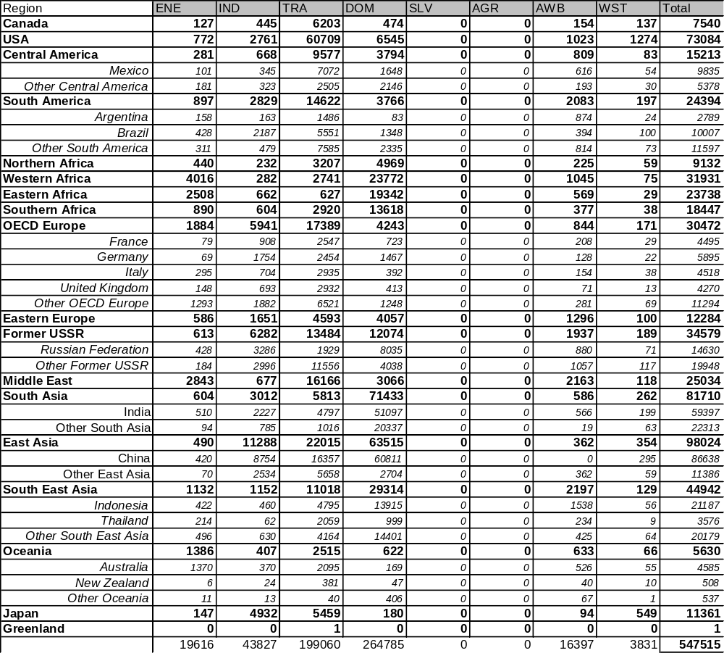
Table 3: CO emissions by world region including detail for selected countries based on the median value of all inventories.

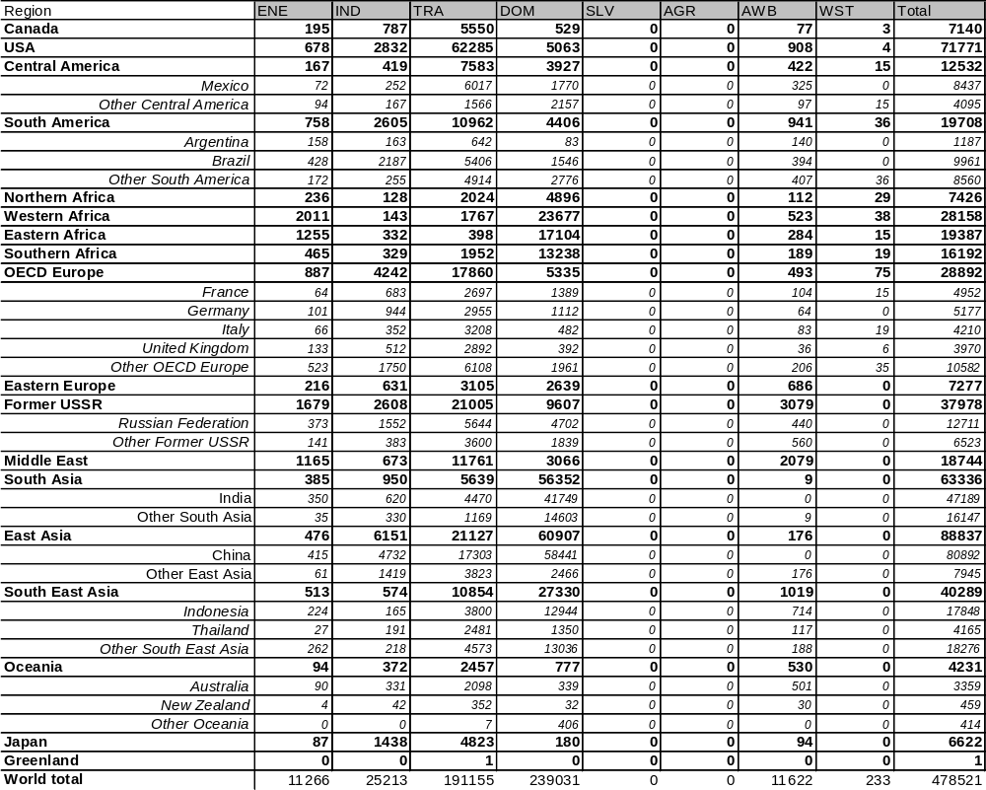
Table 4: Overview of emissions by sector from all inventories considered in this analysis.

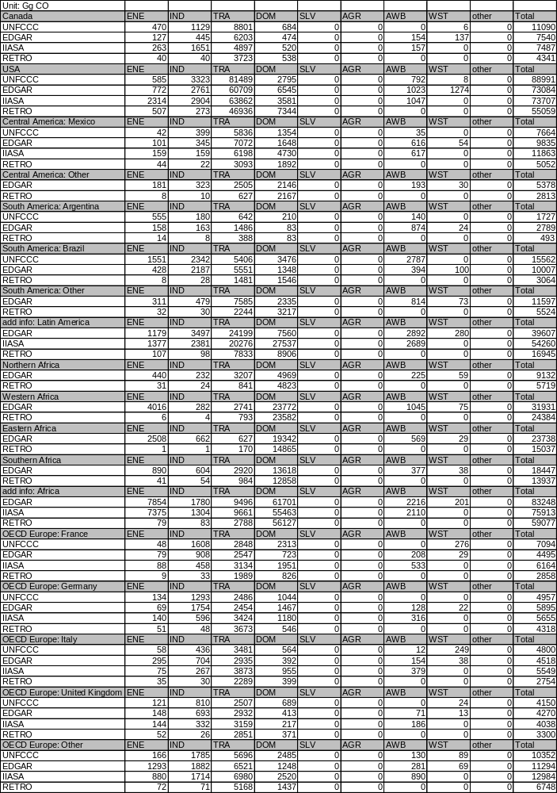
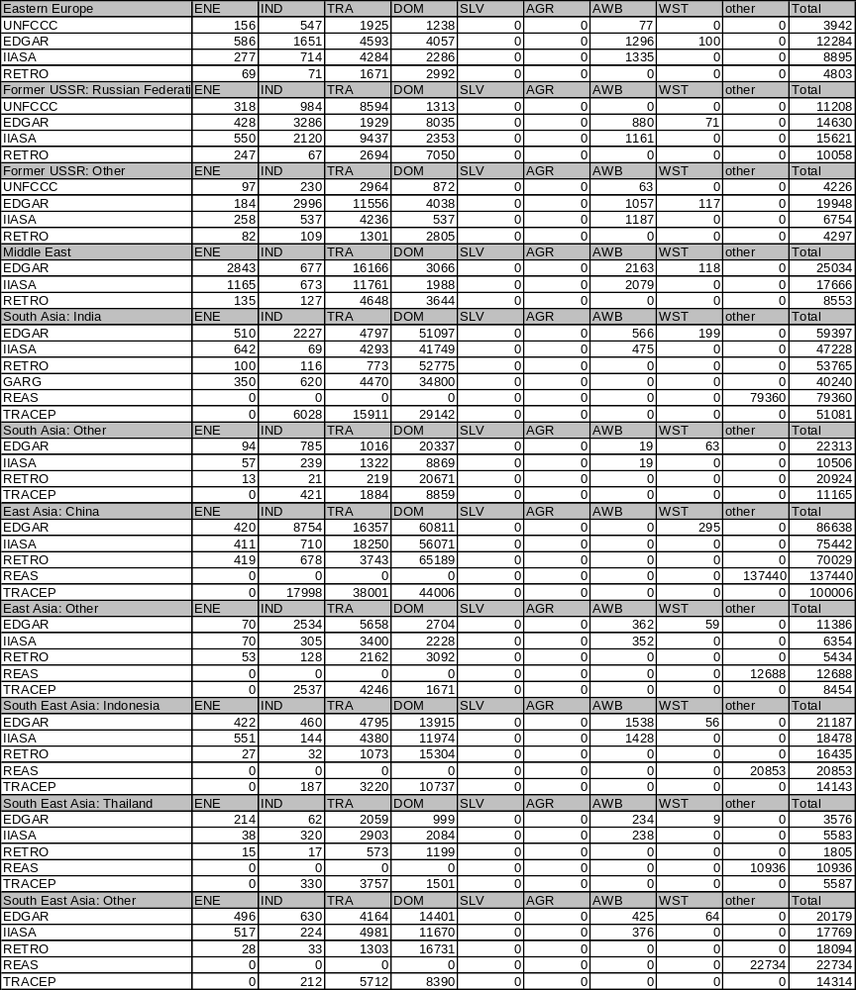
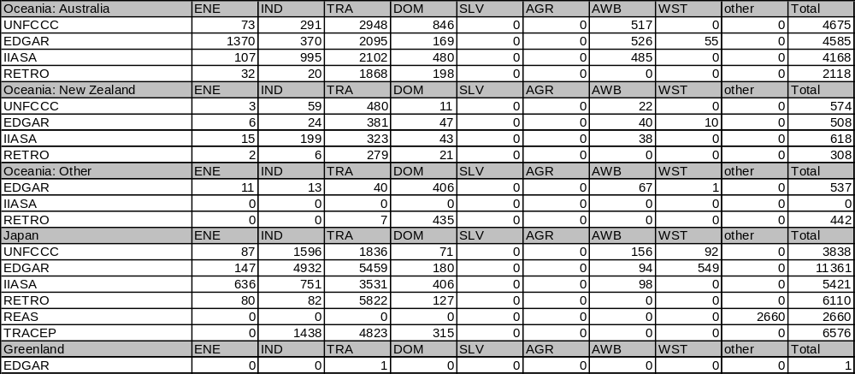
References:

Dentener F., Stevenson D., Cofala J., Mechler R., Amann M., Bergamaschi P., Raes F., Derwent D. The impact of air pollutant and methane emission controls on Tropospheric Ozone and radiative forcing: CTM calculations for the period 1990-2030. Atmos. Chem. Phys. Discuss., 4, 1-68, 2004.
Dentener et al. (2004).

Schultz, M. (ed). REanalysis of the TROpospheric chemical composition over the past 40 years (RETRO) — A long-term global modeling study of tropospheric chemistry
Final Report Jülich/Hamburg, Germany, August 2007
Published as report no. 48/2007 in the series „Reports on Earth System Science“ of the Max Planck
Institute for Meteorology, Hamburg, ISSN 1614-1199

Cofala et al. (not dated). http://www2.nilu.no/farcry_accent/files/Globalemissionsofairpollutants.pdf

Olivier, J.G.J., Van Aardenne, J.A., Dentener, F., Ganzeveld, L. and J.A.H.W. Peters (2005). Recent trends in global greenhouse gas emissions: regional trends and spatial distribution of key sources. In: Non-CO2 Greenhouse Gases (NCGG-4), A. van Amstel (coord.), page 325-330. Millpress, Rotterdam, ISBN 905966 043 9.

Van Aardenne, J.A., F. Dentener, J.G.J. Olivier and J.A.H.W. Peters (2005). The EDGAR 3.2 Fast Track 2000 dataset (32FT2000) http://www.mnp.nl/edgar/model/v32ft2000edgar/docv32ft2000.

Streets, D. G., et al. (2003), An inventory of gaseous and primary aerosol emissions in Asia in the year 2000, J. Geophys. Res., 108(D21), 8809, doi:10.1029/2002JD003093.[

Ohara, T., Akimoto, H., Kurokawa, J., Horii, N., Yamaji, K., Yan, X., and Hayasaka, T.: An Asian emission inventory of anthropogenic emission sources for the period 1980–2020, Atmos. Chem. Phys., 7, 4419-4444, 2007.

Zhang, Q., et al. (2007), NOx emission trends for China, 1995–2004: The view from the ground and the view from space, J. Geophys. Res., 112, D22306, doi:10.1029/2007JD008684.

Garg, A. P.R. Shukla, M. Kapshe (2006). The sectoral trends of multigas emissions inventory of India. Atmospheric Environment 40, 4608-4620.

